**Title:** Age driven phenotypic variation of a foundation tree species structures co-occurrence networks

**Authors:** Matthew K. Lau, Louis J. Lamit, Rikke. R. Naesborg, Thomas G. Whitham

**Abstract**

* Understanding the community level impacts of intraspecific trait variation is integral to understanding community dynamics
* Previous studies have shown that genetically based intraspecific variation can influence the interactions among species; however, no studies have been done that examine these effects in the assembly of a whole community of interacting species.
* Here, we use null modeling and network analysis based methods in a model system of epiphytic lichen to examine the effect of phenotypic variation in a foundation tree species (*Populus angustifolia*) on a network of interacting species.
* Three main results emerged:

1. Species tended to cluster together at the scale of both the stand (SES = -20.51, P < 0.001) and individual tree (Mean = -4.25, SE = 0.96),
2. Co-occurrence patterns were strongly related to bark roughness (R2 = 0.42, P = 0.0127),
3. A Structural Equation Model (SEM) showed that tree age indirectly influences co-occurrence patterns via bark roughness (R2 = 0.42, χ2 = 0.38, P = 0.539).

* These results show tree trait variation can contribute significantly to the co-occurrence patterns and thus the network of interactions among species in tree dependent organisms. Given that this trait has an underlying genetic basis, these results suggest that evolutionary dynamics could play a role in determining the interactions among species in complex communities.

Tables

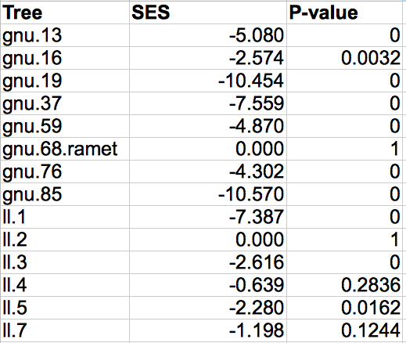

Table 1. Table of the Standardized Effect Sizes (SES) and associated left tail P-values for the surveyed trees.

Figures

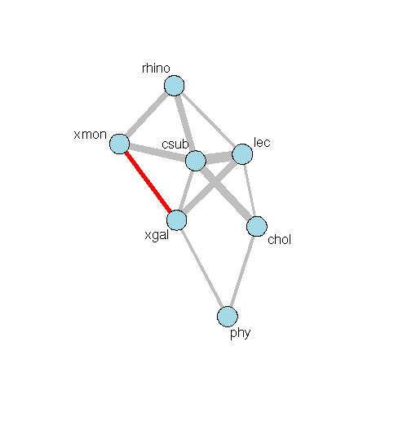

Figure 1. Network showing the co-occurrence patterns for the epiphytic lichen community at the scale of the stand. Points show each species and lines show significant spatial dependencies scaled by the magnitude and colored grey if positive and red if negative.

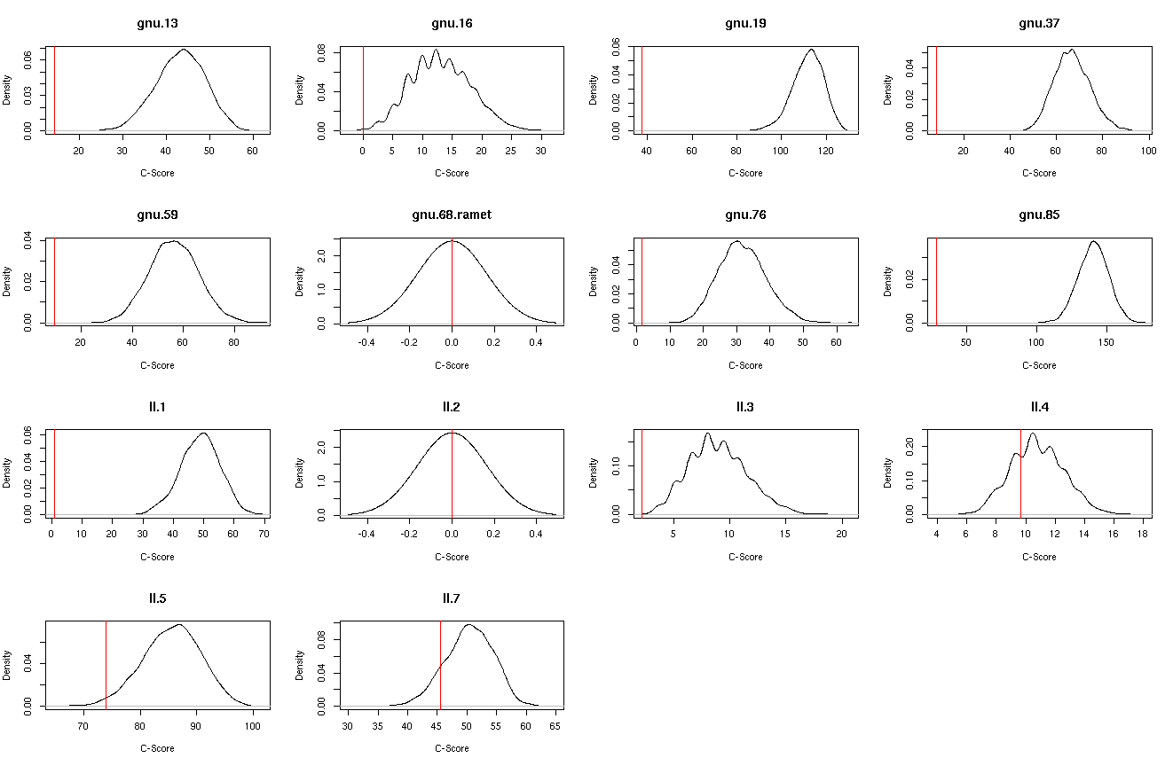

Figure 2. Array of the density plot for the null simulated c-scores used to calculate the Standardized Effect Sizes for the community on each tree.

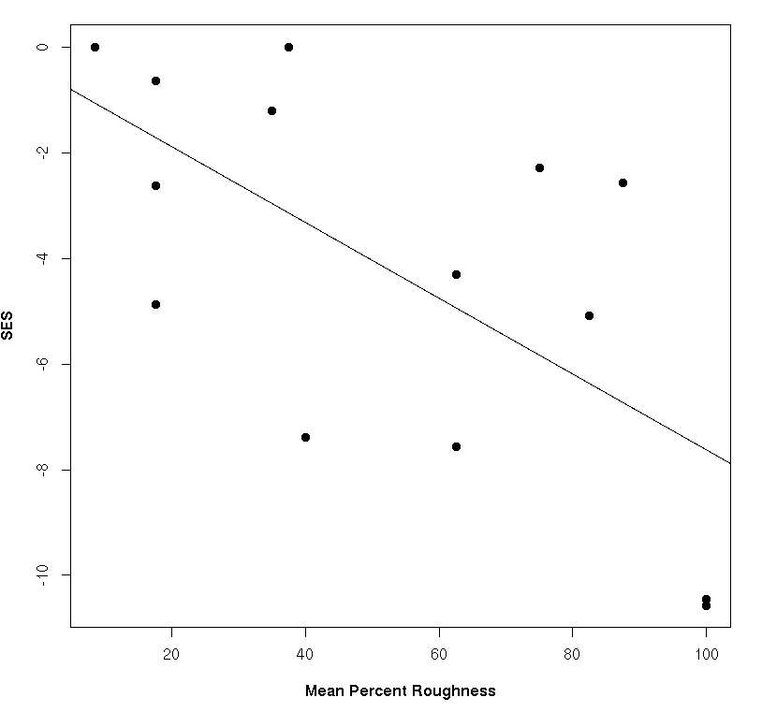

Figure 3. Plot showing the significant effect of bark roughness on the co-occurrence patterns (SES) of lichen communities on each tree.

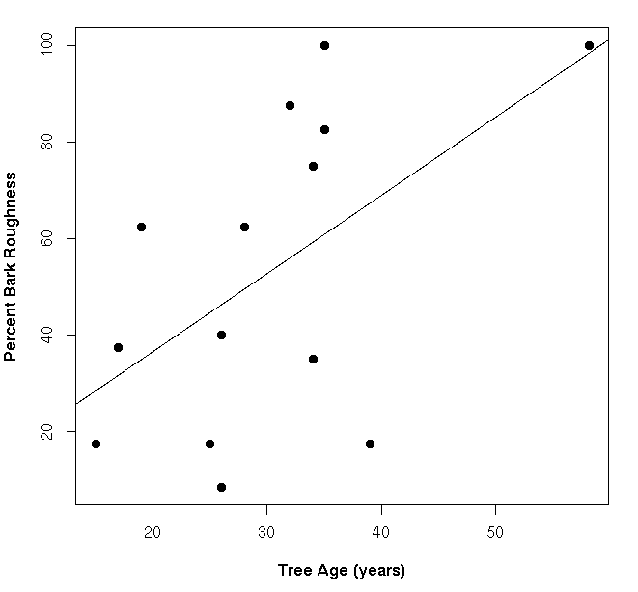

Figure 4. Plot showing the significant relationship between tree age and bark roughness.

Macintosh HD:Users:Aeolus:projects:dissertation:projects:lichen_coo:results:sem_coo.png

Figure 5. Path diagram showing the Structural Equation Model (SEM) in which the indirect effect of tree age is compared to the direct effect of bark roughness on lichen co-occurrence patterns (SES).